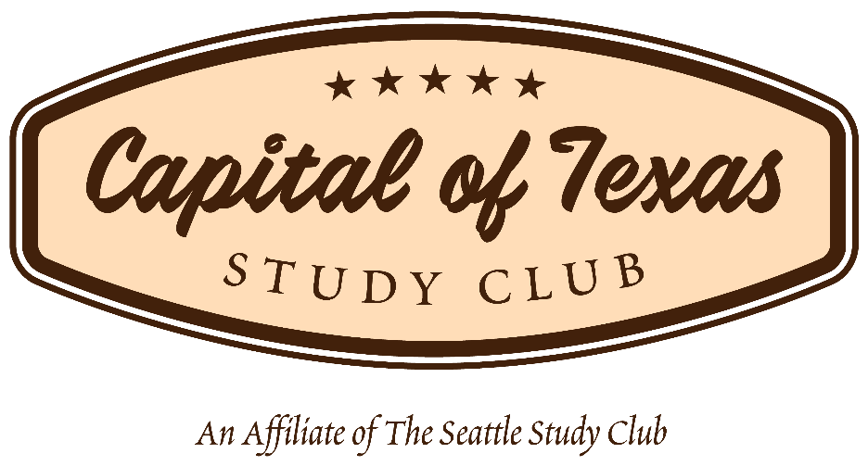
PRELIMINARY SCHEDULE FOR ACADEMIC YEAR 2017-18

October 5, 2017 (Thursday) at 6:30 p.m.
Kick-Off Dinner at Rocco’s Grill

November 7, 2017 (Tuesday) at 6:30 p.m.
Problem-Solving Workshop at TBD

November 28, 2017 (Tuesday) at 6:30 p.m.
“Minimally Invasive Concepts and Treatment”
Live Stream Education with Gregg Kinzer at TBD

January 9, 2018 (Tuesday) at 6:30 p.m.
“Evening of Patients at Risk” at TBD

January 15-20, 2018 at Palm Springs, California
Seattle Study Club Symposium
(Separate registration)

February 2, 2018 (Friday) at 8:00 a.m.
Morning Session for doctors & staff: “Innovative, Progressive, Authentic: The Art and Science Behind Team Synergy & Success” with Greg Tice
Afternoon Session for doctors only: “Interdisciplinary Treatment Planning Workshop”
with Dr. Michael Cohen
Full Day Program at TBD

March 6, 2018 (Tuesday) at 6:30 p.m.
“High Intensity Learning” at TBD

April 6, 2018 (Friday) at 8:00 a.m.
Full Day Diagnostic Program with Dr. Parag Kachalia and KavoKerr at Sonesta Bee Cave

May 1, 2018 (Tuesday) at 6:30 p.m.
“Comprehensive Treatment Planning” at TBD

June 7, 2018 (Thursday) at 6:30 p.m.
Final Gala Dinner at TBD

